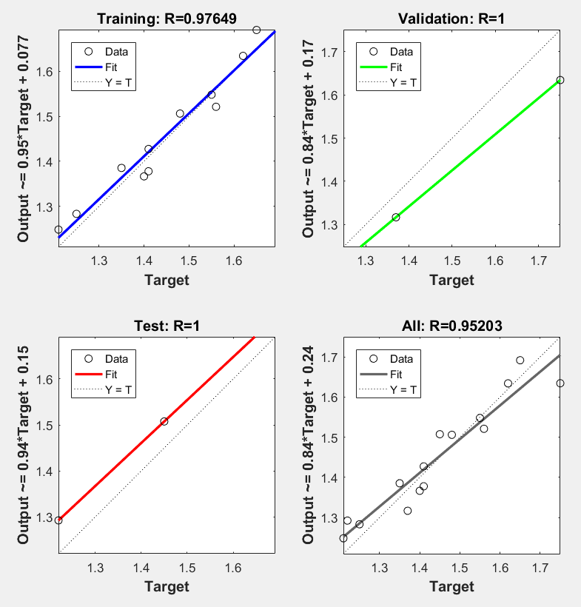

O = -0.2796 × Y1 0.3680 × Y2 -0.1090 × Y3 0.8176 × Y4 -0.7546 × Y5 -0.3374 × Y6 0.6034 × Y7 -0.2695 × Y8 0.1786 × Y9 -0.7863 × Y10 0.2319

Y1 = Tansig( -0.9242 × A -1.0330 × B -0.9671 × C 0.1479 × D 1.4302 × E ) + ( 2.2225 )

Y2 = Tansig( 0.5035 × A -0.4605 × B -2.3462 × C -0.0622 × D 0.1249 × E ) + ( -1.0321 )

Y3 = Tansig( -1.3925 × A 0.9649 × B -0.8682 × C 1.0480 × D -0.4484 × E ) + ( 1.2502 )

Y4 = Tansig( -1.1566 × A -0.5069 × B -0.8969 × C -0.4866 × D 1.4634 × E ) + ( 0.4658 )

Y5 = Tansig( 0.5240 × A -1.4145 × B -0.3794 × C 0.9515 × D 1.3808 × E ) + ( -0.6086 )

Y6 = Tansig( 0.2875 × A 0.2121 × B 1.4675 × C -1.1223 × D 1.1677 × E ) + ( 0.3518 )

Y7 = Tansig( -0.3951 × A -0.7717 × B -0.3574 × C -1.7715 × D -0.9325 × E ) + ( -0.3221 )

Y8 = Tansig( 1.3124 × A -1.5337 × B -0.3665 × C -0.9653 × D -1.0988 × E ) + ( 0.9929 )

Y9 = Tansig( -1.1867 × A 0.8760 × B -0.3741 × C 1.3024 × D 1.1681 × E ) + ( -1.5729 )

Y10 = Tansig( 0.9215 × A -0.0138 × B 1.0255 × C -0.6429 × D 1.2715 × E ) + ( 2.5464 )